**TOPIC 3 WAVES AND PARTICLE NATURE OF LIGHT**

**Topic 3B The behavior of waves**

1. The diagram below shows two sound waves displayed on an oscilloscope screen. Which of the following gives the phase difference in degrees between the two signals?

**A $\frac{λ}{6}$**

**B** 90°

**C $\frac{2π}{3}$**

**D** 180°

## Your answer

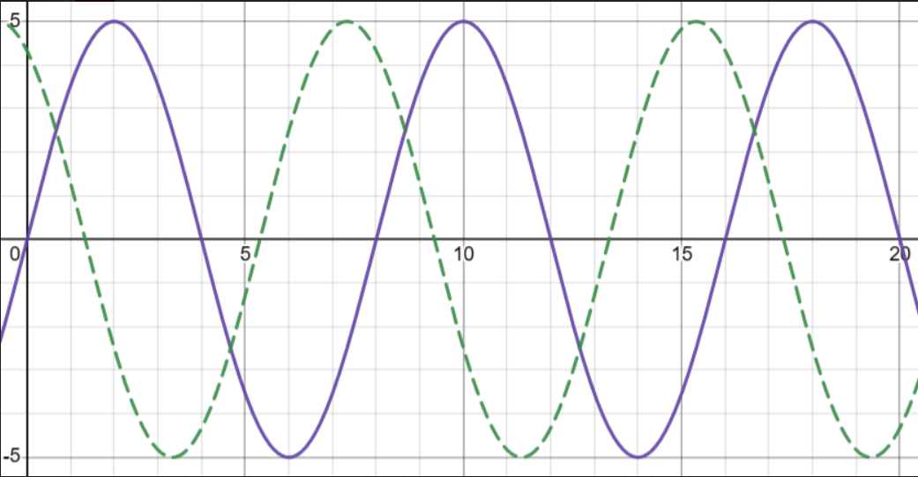

**(1)**

**(Total for Question 1 = 1 mark)**

1. The diagram below shows an experimental set-up used by a teacher to demonstrate superposition effects. The two loudspeakers, S1 and S2, are connected to the same signal generator so that they emit sound waves in phase and of the same frequency and amplitude. The teacher moves a microphone

(at M) along line AB and displays the signal from the microphone on the oscilloscope screen. The signal generator is set to a frequency of 720 Hz and the speed of sound in the laboratory is 330 ms–1.

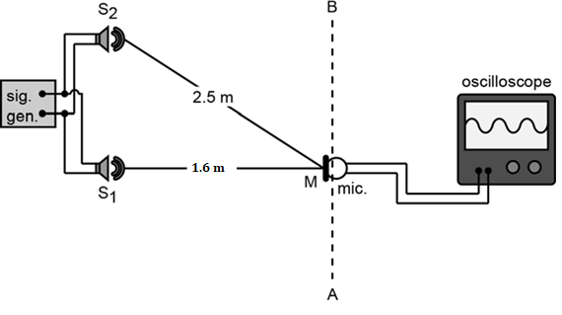

* 1. Explain why the speakers are *coherent* sources.

## (1)

..............................................................................................................................................................

* 1. (i) State the value of the path difference in metres for sounds reaching the microphone when it is at M, as shown in the diagram.

## (1)

..............................................................................................................................................................

1. Calculate the wavelength difference between the waves from S1 and S2 at M.

## (2)

..............................................................................................................................................................

..............................................................................................................................................................

1. What do you conclude about the amplitude of sound at M? Explain your answer.

## (2)

..............................................................................................................................................................

..............................................................................................................................................................

* 1. Describe and explain how the amplitude of the trace on the oscilloscope would change as the teacher moved the microphone from M to B.

## (5)

..............................................................................................................................................................

..............................................................................................................................................................

..............................................................................................................................................................

..............................................................................................................................................................

..............................................................................................................................................................

## (Total for Question 2 = 11 marks)

1. Microwaves inside a microwave oven can set up patterns of standing waves.
   1. Explain what is meant by a ‘standing wave’ and suggest how these might be formed inside a microwave oven.

## (3)

..............................................................................................................................................................

..............................................................................................................................................................

..............................................................................................................................................................

* 1. When food is cooked in a microwave oven it is placed on a rotating plate. Why is it important to rotate the food during cooking?

## (2)

..............................................................................................................................................................

..............................................................................................................................................................

## (Total for Question 3 = 5 marks)

1. Which of the following statements about waves is incorrect?

**A** Sound waves can reflect and refract but they cannot be polarized.

**B** It is impossible to set up a standing wave pattern with visible light.  
**C** All electromagnetic waves travel at the same speed in a vacuum.   
**D** Low frequency sounds diffract more than high frequency sounds.

## Your answer

**(1)**

1. A vertical polarising filter is set up in front of a source of unpolarised white light. A second polarising filter is placed parallel to the first and slowly rotated through 90°. Sketch a graph to show how the intensity of light transmitted through the two filters varies with angle from 90° to 270°.

## (2)

**(Total for Question 5 = 2 marks)**

**TOPIC 3 WAVES AND PARTICLE NATURE OF LIGHT**

**Topic 3C More wave properties of light**

1. Which of the following optical devices is based on reflection of light?

**A** Microscope **B** endoscope **C** Telescope **D** Camera

## Your answer

**(1)**

**(Total for Question 1 = 1 mark)**

1. Which line of the table below states what happens to the speed, wavelength and frequency of red light as it passes from air into water ?

|  |  |  |  |
| --- | --- | --- | --- |
|  | **Speed** | **Wavelength** | **Frequency** |
| **A** | increases | increases | increases |
| **B** | reduces | reduces | increases |
| **C** | increases | increases | stays the same |
| **D** | reduce | reduces | stays the same |

## Your answer

**(1)**

**(Total for Question 2 = 1 mark)**

1. The photograph shows waves in a ripple tank passing through a gap in a barrier.

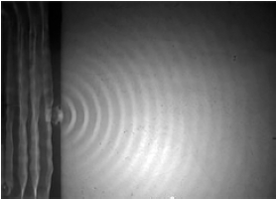

Which of the following properties of waves is being demonstrated as the waves pass through the gap?

   **A**    diffraction

   **B**    reflection

   **C**    refraction

   **D**    superposition

Light from a lamp passes through two polarising filters, P1 and P2, before reaching a detector. Each filter can be rotated through an angle as shown.

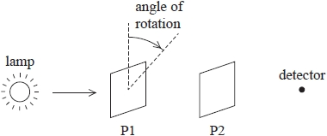

The filters initially have their planes of polarisation perpendicular to each other.

The intensity of light at the detector will be greatest if

**(1)**

   **A**    P1 is rotated by 45° and P2 is rotated by 315° in the same direction.

   **B**    P1 is rotated by 90° and P2 is rotated by 270° in the same direction.

   **C**    P1 is rotated by 45° and P2 is rotated by 270° in the same direction.

   **D**    P1 is rotated by 90° and P2 is rotated by 315° in the same direction.

## (1)

The diagram shows the path of a ray of light into a glass block.

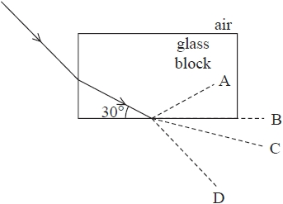

The critical angle for the glass-air boundary is 40°.

Which dotted line represents the continuing path of the ray of light?

   **A**       **B**    **C**    **D**

* 1. Blue light travels more slowly in glass than red light. How would this affect the angles of refraction ?

## (2)

..............................................................................................................................................................

..............................................................................................................................................................

## (Total for Question 3 = 3 marks)

1. A woman is windsurfing on a sunny day. There is a lot of glare from the light reflected off the water.
   1. State what happens to the light that is reflected off the water.

## (1)

..............................................................................................................................................................

* 1. The woman wears Polaroid sunglasses to reduce the glare. Explain how they reduce the glare.

## (2)

..............................................................................................................................................................

..............................................................................................................................................................

* 1. The windsurfer now wants to be able to see an obstruction under the surface of the water. She rotates her head through 90 degrees to the side. Explain why she does this.

## (1)

..............................................................................................................................................................

## (Total for Question 4 = 4 marks)

5 The photograph shows a shoe with novelty shoelaces.

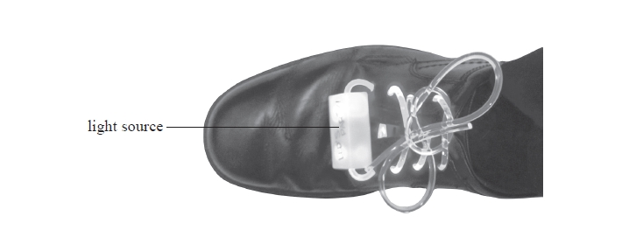

The laces are long, flexible plastic strands. Light from the light source passes through   
the tied laces, illuminating the ends.

(a)  (i)  State what is meant by critical angle.

**(2)**

.............................................................................................................................................

.............................................................................................................................................

.............................................................................................................................................

(ii)  Show that the refractive index for the plastic used for the laces is about 1.5

       speed of light in plastic = 1.97 × 108 m s−1

**(2)**

.............................................................................................................................................

.............................................................................................................................................

.............................................................................................................................................

.............................................................................................................................................

(iii)  Calculate the critical angle for the plastic used for the laces.

**(2)**

.............................................................................................................................................

.............................................................................................................................................

.............................................................................................................................................

.............................................................................................................................................

Critical angle = ...........................................................

(b)  Explain how light from the source is able to reach the end of the laces.

**(2)**

.............................................................................................................................................

.............................................................................................................................................

**TOPIC 3 WAVES AND PARTICLE NATURE OF LIGHT**

**Topic 3D Quantum physics**

1. Which of the following experiments provides evidence for the particle nature of light?
   1. The diffraction of electrons as they pass through a layer of graphite
   2. The diffraction orders formed when light passes through a diffraction grating
   3. The ejection of photoelectrons from zinc when ultraviolet light falls on it
   4. The interference pattern formed in Young’s double slit experiment

## Your answer

**(1)**

**(Total for Question 1 = 1 mark)**

1. Which of the following characteristics of the photoelectric effect cannot be explained by the wave theory of light?
2. The rate of transfer of energy from light to the metal surface is proportional to the intensity of the light source.
3. Increasing the intensity of light above the threshold frequency increases the rate of emission of photoelectrons.
4. Increasing the intensity of light below the threshold frequency does not result in the emission of photoelectrons.
5. The intensity of the light can be varied independently of its frequency.

## Your answer

**(1)**

**(Total for Question 2 = 1 mark)**

1. The table below gives the photoelectric work functions for several different metals. The Planck constant *h* = 6.6  10−34 Js. The magnitude of charge on an electron *e* = 1.6  10−19 C.

|  |  |
| --- | --- |
| **Metal** | **Work function/eV** |
| Potassium | 2.2 |
| Zinc | 4.2 |
| Iron | 4.5 |
| Silver | 4.7 |

1. Explain what is meant by the work function.

## (1)

..............................................................................................................................................................

1. Convert the work function for zinc to J.

## (1)

..............................................................................................................................................................

1. Which of the metals above has the highest threshold frequency? Explain your answer.

## (2)

..............................................................................................................................................................

..............................................................................................................................................................

1. The diagram below shows an experimental arrangement used to measure the stopping voltage for a photocell. This particular cell uses potassium as the emitter and is illuminated by a source of yellow light of wavelength 590 nm.

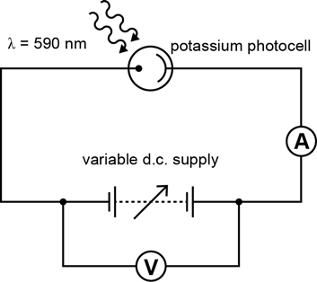

* 1. Calculate the energy of a photon of light of wavelength 420 nm. Give your answer in both J and eV.

## (2)

..............................................................................................................................................................

..............................................................................................................................................................

* 1. Calculate the maximum kinetic energy of photoelectrons emitted from potassium by light of wavelength 420 nm.

## (2)

..............................................................................................................................................................

..............................................................................................................................................................

* 1. Calculate the stopping voltage for this experiment.

## (1)

..............................................................................................................................................................

## (Total for Question 3 = 9 marks)

1. The diagram below shows an experimental arrangement used to demonstrate the diffraction of electrons.

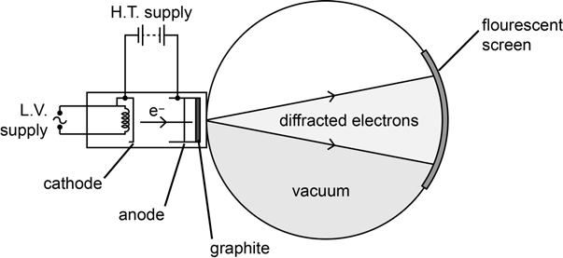

1. Sketch and describe the pattern seen on the fluorescent screen.

## (2)

..............................................................................................................................................................

..............................................................................................................................................................

1. State and explain how the pattern would change if the accelerating voltage was increased.

## (2)

..............................................................................................................................................................

..............................................................................................................................................................

## (Total for Question 4 = 4 marks)

1. The energy of the *n*th level of the hydrogen atom is given by the equation:

13.6 eV

E*n* = *n*2

1. Calculate the energies of the *n* = 1 and *n* = 3 levels.

## (2)

..............................................................................................................................................................

..............................................................................................................................................................

1. Calculate the wavelength of the spectral line emitted by hydrogen when electrons jump from the *n* = 3 level down to the *n* = 1 level.

## (3)

..............................................................................................................................................................

..............................................................................................................................................................

..............................................................................................................................................................

## (Total for Question 5 = 5 marks) TOTAL FOR ASSESSMENT = 60