Questions
Q1. A woman supports a stationary wheelbarrow by exerting an upward force P on the handles. An upward force R from the ground acts on the wheel, as shown.
The centre of gravity G of the wheelbarrow is marked on the diagram.
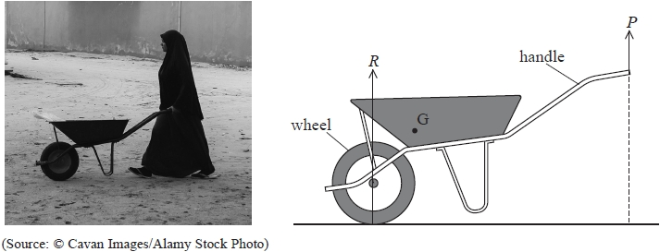
(a) Explain, by considering moments about G, why P is less than R.
(3)
.............................................................................................................................................
.............................................................................................................................................
.............................................................................................................................................
.............................................................................................................................................
(b) The horizontal distance between the centre of the wheel and the handles is 1.5 m.
The magnitudes of P and R are as shown.
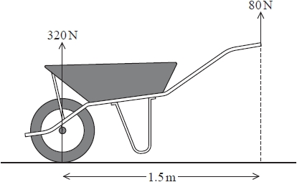
Determine the horizontal distance between the centre of gravity of the wheelbarrow and the centre of the wheel.
(4)
.............................................................................................................................................
.............................................................................................................................................
.............................................................................................................................................
.............................................................................................................................................
.............................................................................................................................................

Q2. The diagram shows two bumper cars, P and Q, at an amusement park.

Q was stationary. P was moving at a speed of 2.10 m s⁻¹ towards Q.
P collided with Q. After the collision, P and Q moved off in the same direction. P moved with a speed of 1.15 m s⁻¹. Q moved with a speed of 1.57 m s⁻¹.
(a) (i) Show that the total mass of Q was about 150 kg.
total mass of P = 250 kg
(3)
.............................................................................................................................................
.............................................................................................................................................
.............................................................................................................................................
.............................................................................................................................................
(ii) State one assumption you made in your calculation in (a)(i).
(1)
.............................................................................................................................................
.............................................................................................................................................
(iii) The collision lasted a total time of 1.35 s.
Calculate the average horizontal force on Q during the collision.
(3)
.............................................................................................................................................
.............................................................................................................................................
.............................................................................................................................................
.............................................................................................................................................
.............................................................................................................................................
Average horizontal force = ...........................................................
(b) Explain why P decelerates during the collision. Your answer should make reference to Newton's laws of motion.
(3)
.............................................................................................................................................
.............................................................................................................................................
.............................................................................................................................................
.............................................................................................................................................

Q3. A skittle is a wooden object that can stand upright on one end.
In a game of Skittles, a ball is thrown at some skittles to knock them over, as shown.
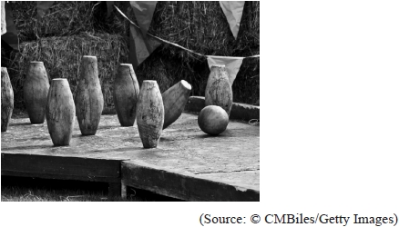
The diagram below shows the ball just before it collides with a skittle.
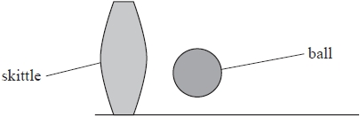
(a) The graph shows how the velocity of the skittle varies with time. The time shown on the graph starts just before the ball hits the skittle.
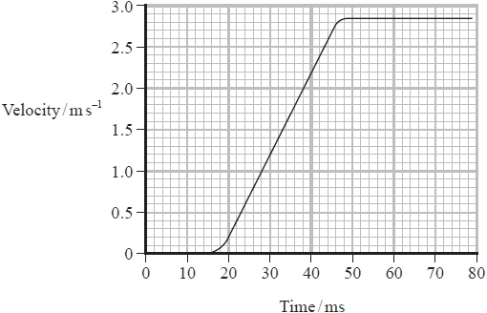
Determine the average acceleration of the skittle during the collision.
(3)
.............................................................................................................................................
.............................................................................................................................................
.............................................................................................................................................
.............................................................................................................................................
.............................................................................................................................................
Average acceleration = ...........................................................
*(b) Explain how Newton's second and third laws of motion apply to the ball and the skittle during the collision.
(6)
.............................................................................................................................................
.............................................................................................................................................
.............................................................................................................................................
.............................................................................................................................................
.............................................................................................................................................
(c) The ball is thrown again, and collides with another stationary skittle.
During the collision the horizontal velocity of the ball changes from 7.2 m s^{–1} to 1.6 m s^{–1} .
The horizontal velocity of the skittle immediately after the collision is 3.1 m s^{–1} in the same direction as the ball.
Determine the mass of the ball.
mass of skittle = 1.4 kg
(3)
.............................................................................................................................................
.............................................................................................................................................
.............................................................................................................................................
.............................................................................................................................................
.............................................................................................................................................
Mass of ball = ...........................................................

(Total for question = 12 marks)

Q4. A spaceship is used to take astronauts and equipment to the International Space Station. The spaceship consists of an orbital module, a descent module and a service module, as shown.
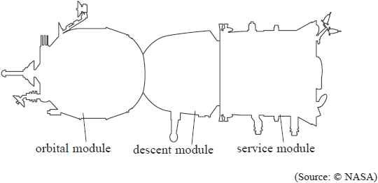
The astronauts return to Earth in the descent module.
Before entering the Earth's atmosphere, the modules separate.
The orbital module (O) and service module (S) move away from the descent module (D) in opposite directions,
as shown below.
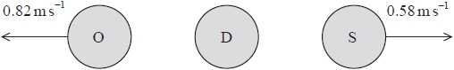
(a) Determine the velocity v of the descent module after separation.
You should only consider momentum along a horizontal line through the centres of the three modules.
mass of O = 1350 kg
mass of D = 2950 kg
mass of S = 2100 kg
(4)
.............................................................................................................................................
.............................................................................................................................................
.............................................................................................................................................
.............................................................................................................................................
Magnitude of v = ........................................................... Direction of v = ...........................................................
(b) The velocity of the descent module can be changed using a rocket motor. The rocket motor ejects hot
gases at high velocity.
(i) Explain why the velocity of the descent module changes when the rocket motor is used.
Your answer should refer to Newton's laws of motion.
(3)
.............................................................................................................................................
.............................................................................................................................................
.............................................................................................................................................
.............................................................................................................................................
.............................................................................................................................................
.............................................................................................................................................
(ii) When the rocket motor is operating, the velocity of the descent module changes by 0.58 m s^{–1}
during a time of 5.0 seconds.
mass of descent module = 2950 kg
Calculate the average force exerted on the hot gas during this time.
(3)
.............................................................................................................................................
.............................................................................................................................................
.............................................................................................................................................
.............................................................................................................................................
Average force = ...........................................................

Q5. The diagram shows a machine used to launch tennis balls in a horizontal direction.
The machine is on frictionless wheels.
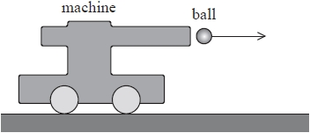
Before a tennis ball is launched, the machine is stationary.
(a) Explain, in terms of momentum, why the machine starts to move as the ball is launched.
(3)
.............................................................................................................................................
.............................................................................................................................................
.............................................................................................................................................
.............................................................................................................................................
.............................................................................................................................................
.............................................................................................................................................
(b) Calculate the velocity of the machine just after the ball is launched.
velocity of ball = 4.5 m s⁻¹
mass of ball = 0.056 kg
mass of machine = 2.9 kg
(3)
.............................................................................................................................................
.............................................................................................................................................
.............................................................................................................................................
.............................................................................................................................................
.............................................................................................................................................
.............................................................................................................................................
Velocity of machine = ...........................................................

(Total for question = 6 marks)

Mark Scheme
Q1.
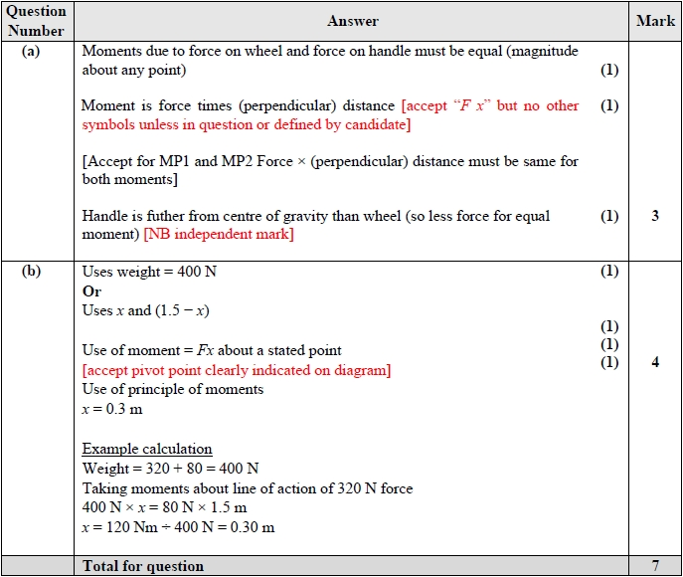

Q2.
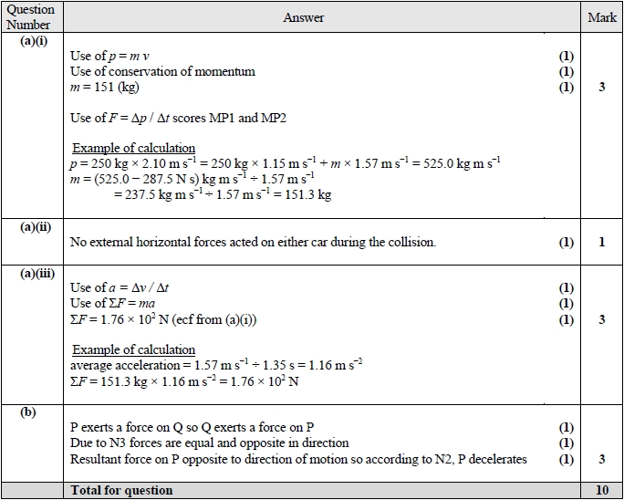

Q3.
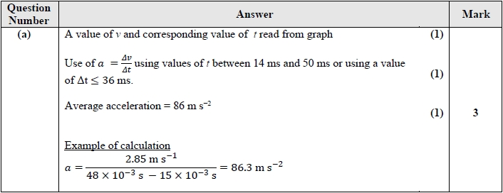
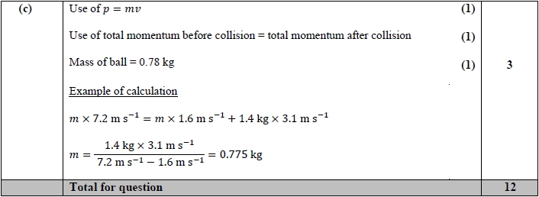
Q4.
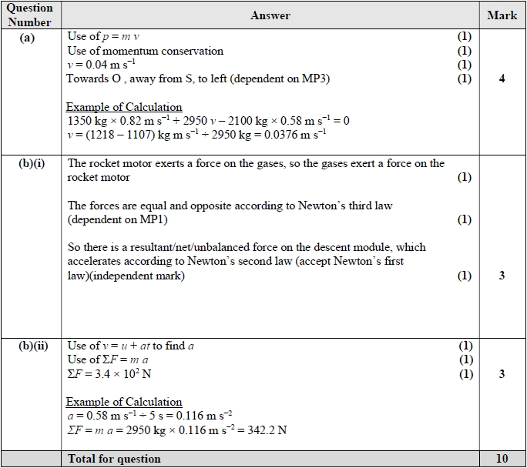

Q5.
