**Chapter 1: Movement and Position**

**1 a** Complete the table below with the correct corresponding quantities and units.

|  |  |
| --- | --- |
| **Quantity** | **Units** |
|  | m |
| displacement |  |
| speed |  |
| velocity |  |
|  | m/s2 |

**b** List which of the quantities above are vectors.

**2** Sarah and Maisie are analysing data from their school sports day. Looking at the 1500 m results for Stephen, Maisie believes that Stephen’s displacement from the start line is 1500 m. Sarah says that she is incorrect and that his displacement from the start is actually 0 m. Which of the students is correct? Give reasoning for your answer.

**3** Velocity is often described as a vector quantity. Speed is not. Describe the difference between a scalar and a vector quantity.

**4** Usain Bolt has been credited as the fastest man in the world over 100 m. Below is a distance– time graph of one of his fastest training runs.

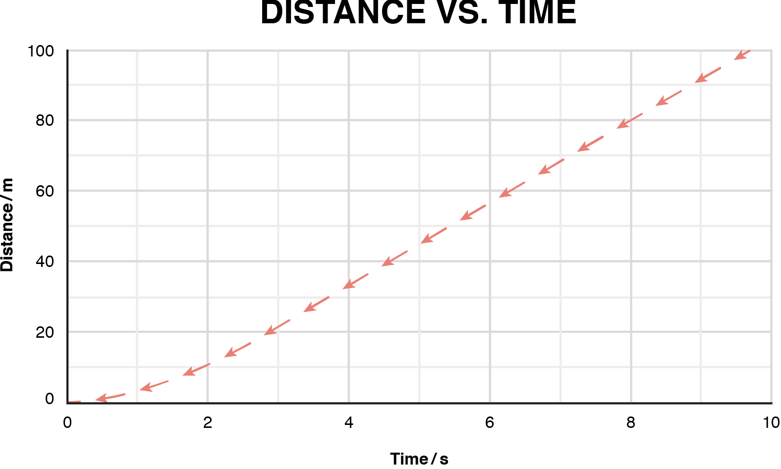

**a** Describe Usain’s motion during the first 2 seconds.

**b** Using the graph above, calculate Usain Bolt’s average speed for the race.

**c** Now calculate his maximum speed.

**d** Suggest one reason why these results differ?

**5** Paul was asked to investigate the velocity of a ball as it rolled down a tilted ramp. He used a data logger at five equally spaced intervals along the ramp to record its velocity at particular points. The results he recorded are in the table below.

|  |  |  |  |  |  |
| --- | --- | --- | --- | --- | --- |
| **Data logger position** | A | B | C | D | E |
| **Velocity/m/s** | 0.9 | 2.9 | 6.0 | 9.8 | 14.8 |
| **Time/s** | 0.5 | 1 | 1.5 | 2.0 | 2.5 |

**a** Using the data, plot a velocity–time graph for Paul’s results.

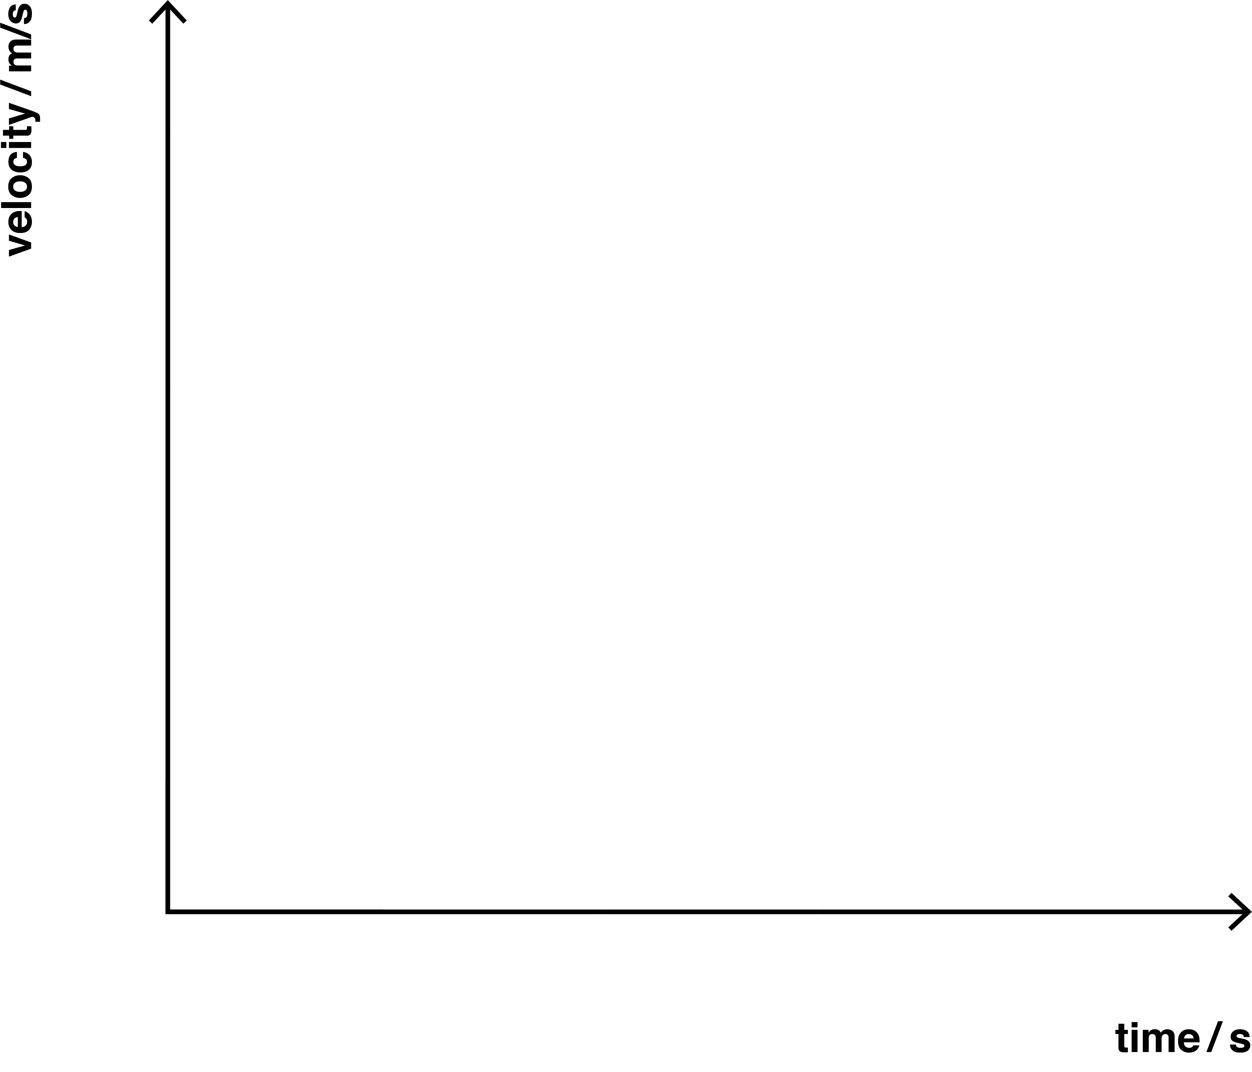

**b** Calculate the acceleration of the trolley down the ramp. Include the units in your answer.

**c** If data logger E is at the end of the ramp, calculate the length of the ramp Paul used.

**6** McLaren racing engineers are testing a variety of new engines in their latest model F1 car. They are testing which engine has the greatest top speed from rest. The engines all accelerate on average at 14.5 m/s2. Theresulting distances are recorded in the table below.

|  |  |  |
| --- | --- | --- |
| **Engine** | **Distance travelled/m** | **Final velocity/m/s** |
| A | 335 |  |
| B | 302 |  |
| C | 290 |  |
| D | 321 |  |

**a** Using the data in the table and the equation *v*2 = *u*2 + 2*as* calculate the final velocities.

**b** One of the engineers noted that each engine’s results were recorded only once. How could any errors in the recording of results be reduced?