**Chapter 15: Electric Motors**

**1** **a** Using Fleming’s left-hand rule, fill in the missing poles, movement or current direction from the diagrams below.

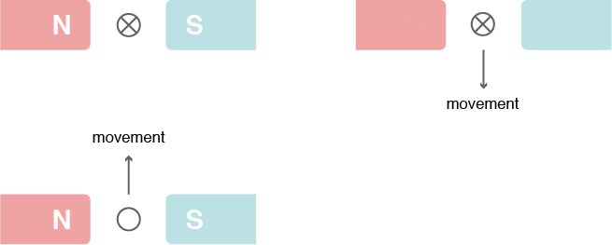

**b** The diagram shows the most important features of a basic motor.

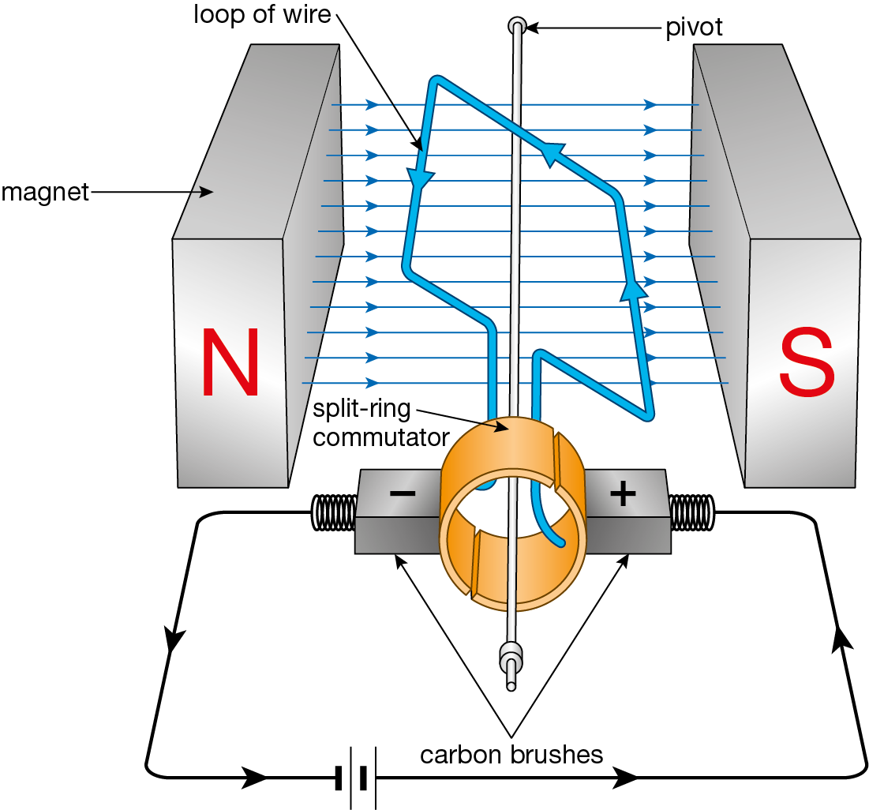

Label on the direction of rotation of the loop of wire.

**c** State three ways in which the speed of rotation of the motor could be increased.

1.

2.

3.

**d** Describe how the motor works.

**2** The diagram below shows a basic diagram of the motor effect.

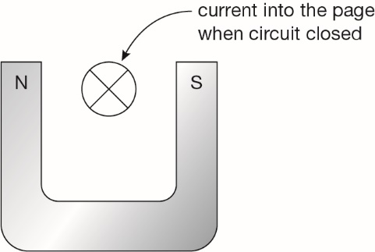

**a** Using Fleming’s left-hand rule, predict the direction in which the wire is going to move when the switch on the circuit is closed. Draw an arrow on the diagram to show the direction of movement of the loop of wire when the circuit is closed.

**b** Explain, using the terms magnetic field, force and current, why the wire will move.

**c** Suggest two examples of where this effect may be used in daily life