**Questions**

**Q1.** The diagram shows the arrangement of particles in a solid, a liquid and a gas.

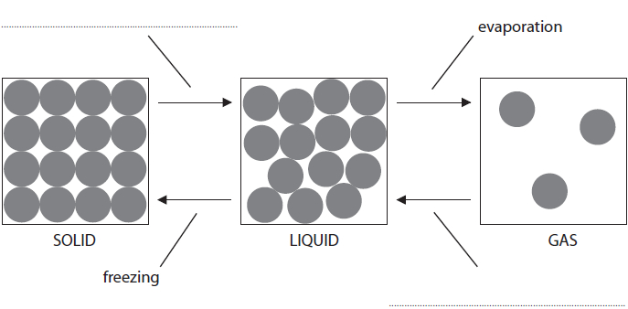

**(a)**  The arrows show the changes of state. Two of the changes of state have been labelled.

**(b)**  Some gas is put in a balloon. Explain, in terms of particles, how the gas exerts a pressure on the inside of the balloon. **(2)**

.............................................................................................................................................

.............................................................................................................................................

.............................................................................................................................................

.............................................................................................................................................

**Q2. A) Answer the question with a cross in the box you think is correct . If you change your mind about an answer, put a line through the box  then mark your new answer with a cross .**

When water boils and turns into steam, there are changes in the speed and arrangement of the water particles. Which row of the table shows these changes correctly?

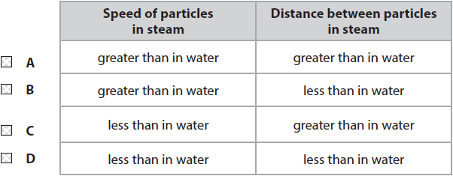

**B) Answer the question with a cross in the box you think is correct . If you change your mind about an answer, put a line through the box  and then mark your new answer with a cross .**

The diagram shows a change of state.

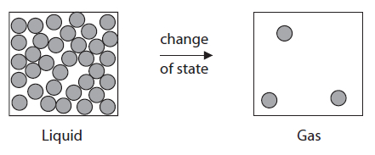

1. What change of state is shown in the diagram?

   **A**    condensing    **B**    evaporation

   **C**    freezing    **D**    melting

1. A wet coat is put on a clothes line on a sunny day.   
    Which statement explains how the coat becomes dry?

   **A**    because water molecules gain energy and condense

   **B**    because water molecules gain energy and evaporate

   **C**    because water molecules lose energy and condense

   **D**    because water molecules lose energy and evaporate

**Q3.** Tick () one box in each row of the table to show the relative charge of each of the particles that are found in atoms.

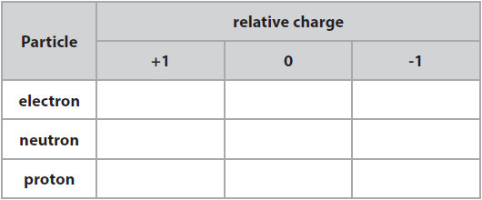

**Q4.** This is the chemical symbol for an atom of an element called chromium.



Complete these sentences.   
**(a)**  The mass number of this atom is ..............................................................

and its atomic number is ............................................................... **(1)**

**(b)**  The number of neutrons in this atom of chromium is ............................................................... **(1)**

**Q5.** The diagrams below show different arrangements of hydrogen and oxygen particles.

Draw **one** line from each diagram to its correct description. One line has been drawn for you.

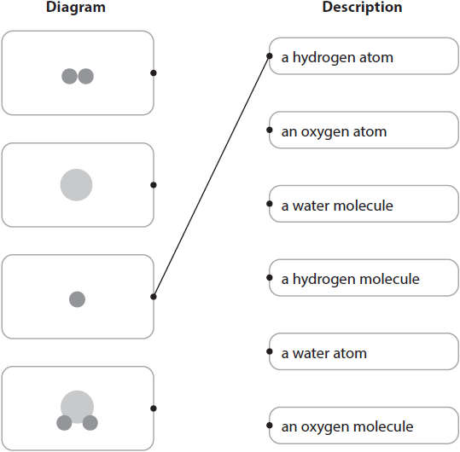

**Q6.** The diagram shows some salt being dissolved in water to make a mixture of salt and water.

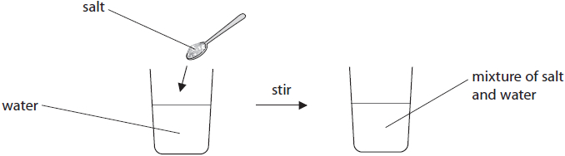

Complete the sentences below using words from the box.



When the salt has dissolved in the water a ....................................................... is formed.

In this process the water is the ................................... and the salt is the ....................................

**Q7.** Different methods can be used to separate a substance from a mixture.  
 Draw **one** straight line from each method of separation to its possible use.

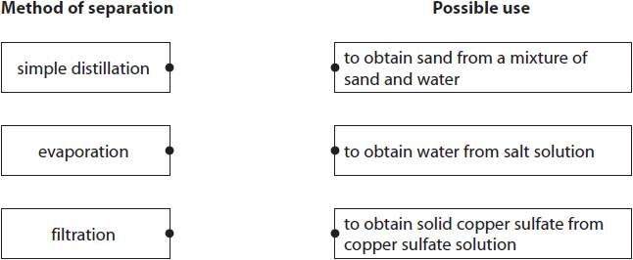

**Q8. Answer the question with a cross in the box you think is correct . If you change your mind about an answer, put a line through the box  and then mark your new answer with a cross .**

The chemical formula for one molecule of carbon dioxide is CO2 how many atoms are in one molecule of carbon dioxide?

   **A**    1    **B**    2    **C**    3    **D**    4

1. An atom of aluminium can be represented by the symbol



1. How many neutrons are there in this atom of aluminium?

   **A**    13    **B**    14    **C**    27    **D**    40

**Q9.** The diagram shows the chromatogram produced using four different inks, P, Q, R and S. Each ink contains three separate coloured dyes.

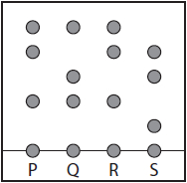

Which two inks contain the same three coloured dyes?

   **A**    P and Q

   **B**    Q and S

   **C**    R and S

   **D**    P and R

**Q10**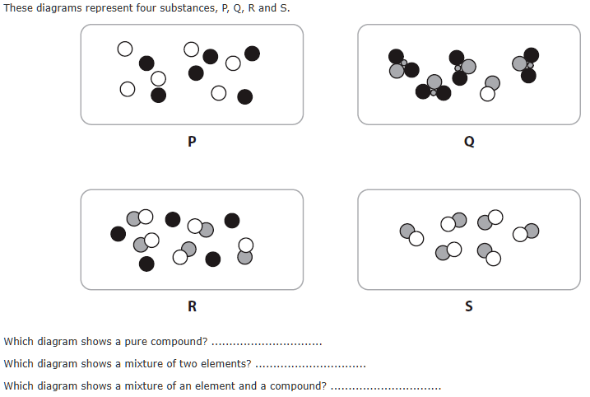  
 **Q11.** The diagram shows two methods of separating mixtures.  
Draw **one** straight line from each method to the mixture it will separate.

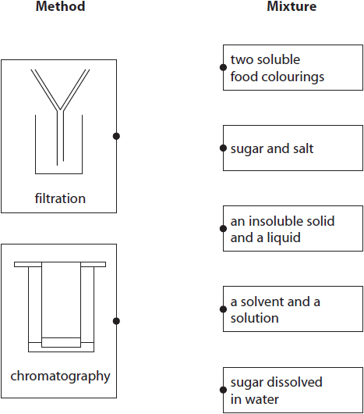

**Q12** Three of the following statements were part of John Dalton's model.  
One of these has been ticked for you. Tick **two** more statements he made.

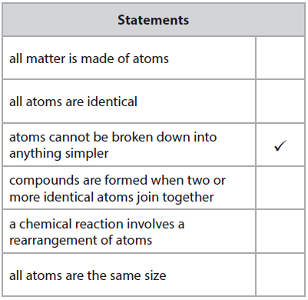

**Q13 Fill in these blanks for the chemical compounds:**

|  |  |
| --- | --- |
| **Material Name** | **Symbol** |
|  | Fe |
| Sodium Hydroxide |  |
|  | Cu |
| Hydrogen |  |
| Helium |  |
| Zinc Chloride |  |
| Calcium Carbonate |  |
| Hydrochloric acid |  |