**Q1**) a crate is lowered into water; it sinks completely as its density is 1200 k*g*/m³. knowing it has a mass of 1700 kg, calculate:  
 a) The volume of the box  
 b) The upthrust force on the box in the water (density of water: 1000 kg/m³)

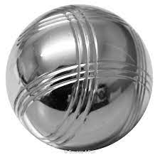**Q2**) a steel sphere with a radius of 12 cm knowing its, calculate:  
 a) the volume of the sphere  
 b) the weight of the water that it displaced  
 c) the upthrust force on it

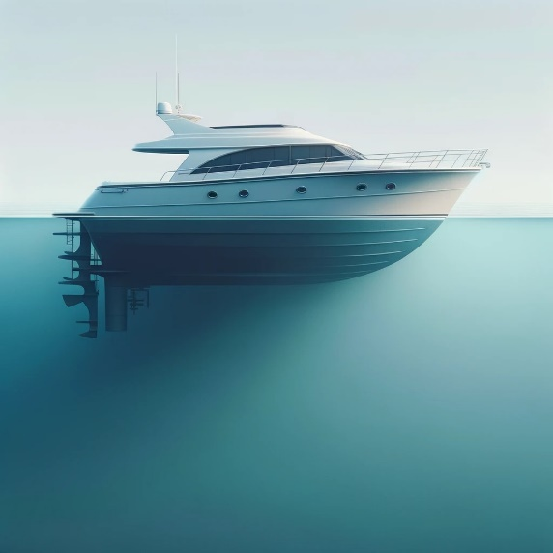**Q3)** a ship’s hull measures 6.3m long, by 2.4m wide, and submerges 1.5m when placed in seawater (d= 1.03 g/cm³),   
 Calculate:

1. The volume of water it displaced
2. The upthrust force on the boat

**Q4)** a ball with a radius of 2 cm, is submerged in oil (d= 0.83 g/cm³),

1. calculate the upthrust force acting on it.
2. What would be the upthrust force acting on it if it were in freshwater (d=1.00*g*/cm³)