Using the graph below, find the resistance of the circuit Resistance: _________ Ohm

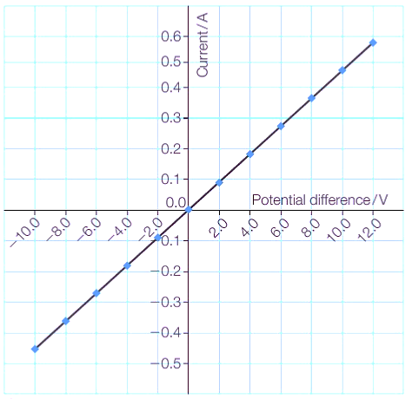

The following circuit consists of a 5V battery, a diode and a resistor, if the threshold voltage of the diode is 1.2 V, calculate the current flowing through the resistor using Ohm’s law:

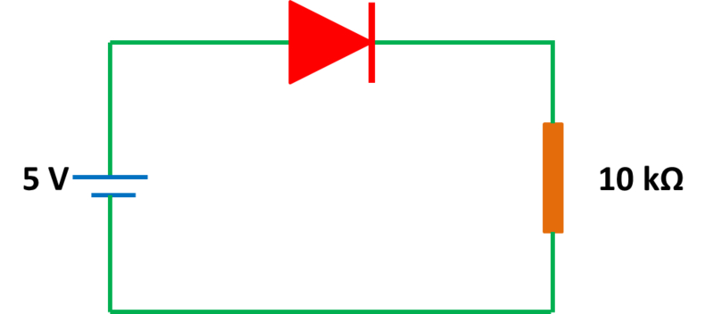

The following are electrical circuits drawn below:   
state one reason why the light bulb in circuit B isn’t working, how would you fix this problem ?

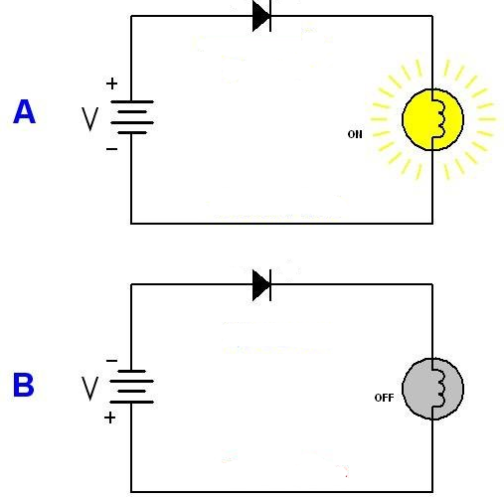

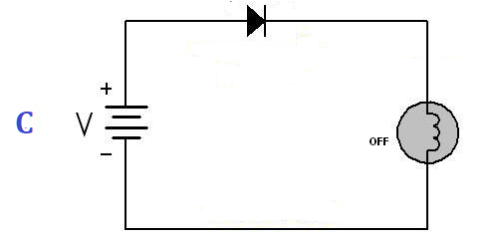After running the lamp in circuit C for a few minutes, it suddenly stopped working,  
explain what physical phenomenon could’ve caused this?   
how can we avoid this problem?