**Q1)** A certain toaster is rated at 1.00 kW when connected to a 120 V source.   
(a) What current does the toaster carry?   
(b) What is its resistance?   
(c) What current will it carry if connected to a 240 V source?  
(d) provided the toaster’s resistance is constant, what will be its power consumption at 240 V

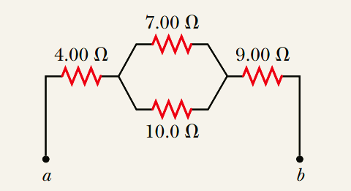**Q2)** Observe the following circuit

1. Draw an ideal cell supplying 34 V  
   to the circuit
2. Add an voltmeter to measure the voltage across the 7Ω resistor
3. What will be the voltmeter’s reading ?

**Q3)** A battery has an emf of 15.0 V. terminal (external) voltage of the battery is 11.6 V when it is delivering 20.0 W of power to an external load resistor R.   
**(a)** What is the value of R?   
**(b)** What is the internal resistance of the battery?

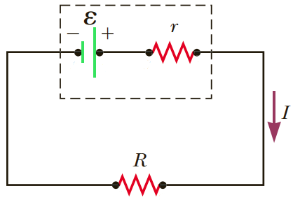

**Q4)** To maximise the useable power from the emf of a battery that is delivered to a device, what should the internal resistance of the battery be? (encircle correct letter)  
 (a) It should be as low as possible.   
 (b) It should be as high as possible.  
 (c) The power does not depend on the internal resistance.

Both ammeters and voltmeters are designed to minimise the disturbance

to the circuits that they are used to test. Should a Voltmeter have   
 (a) a very small resistance   
 (b) a very large resistance   
 (c) an intermediate resistance