**Q1.**A student investigated the power that a battery can supply to a circuit.

The student connected a circuit to determine the electromotive force (e.m.f.)  and internal resistance *r* of the battery. The load resistance *R* was varied. The corresponding readings of current I and terminal potential difference *V* were recorded from an ammeter and a voltmeter.

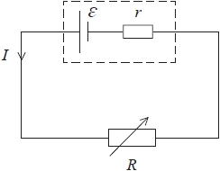

**(a)**  State what is meant by the e.m.f.  of the battery.

**(1)**

.............................................................................................................................................

.............................................................................................................................................

.............................................................................................................................................

**(b)**  (i)  Add to the circuit diagram to show the positions of the ammeter and the voltmeter.

**(2)**

(ii)  Whilst taking the measurements, the student reduced the resistance of the variable resistor to zero.

Suggest why this could be a problem if the battery has a low internal resistance.

**(1)**

....................................................................................................................................................................................................................................

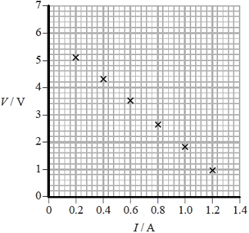**(c)**  The student plotted the results on a graph.

(i)  Determine values for  and *r*. **(4)**

 = ...........................................................

*r* = ...........................................................

(ii)  The power transferred from the battery to the load resistance is a maximum when *R* = *r*.

Calculate the maximum power dissipated in *R*.

**(3)**

Maximum power = ...........................................................

**Q2.** A circuit contains a battery of four cells in series. Each cell has e.m.f. 1.5 V.

A charge of 3.0 C passes through the battery. What is the energy transferred?

   **A**    0.5 J       **B**    2.0 J       **C**    4.5 J        **D**    18 J

**Q3.**A rechargeable cell is labelled 1500 mA h, if the current is 1500 mA for 1 hour, the charge transferred is

   **A**    1.5 C    **B**    90 C    **C**    1500 C    **D**    5400 C

**Q4.** Which of the following is equivalent to a single SI base unit?

   **A**    coulomb per second    **B**    joule per coulomb   
  
   **C**    joule per second    **D**    metre per second

**Q5.** The unit of charge is the coulomb, which of the following is equivalent to a coulomb?

   **A**    A s    **B**    A s–1    **C**    A–1 s    **D**    A–1 s–1

**Q6.** The current in a wire is 25 mA. Calculate the total charge that passes a point in the wire in 200 s.

**(1)**

   **A** 1.25 × 10−4 C   **B** 1.25 × 10−1 C    **C**  5.00 C    **D**  5.00 × 103 C

**Q7.**

Which graph shows how the resistance *R* of a filament bulb varies with temperature *θ* in °C?

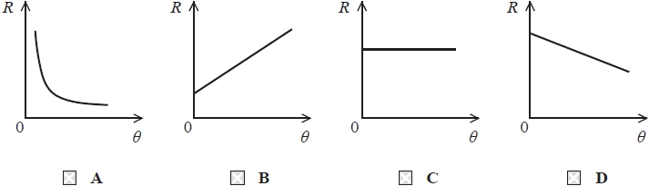

**Q8.** When a charge of 2.0 C passes through a light bulb, 5.0 J of energy is transferred.

What is the potential difference across the bulb?

   **A**    0.4 V    **B**    2.5 V    **C**    3.0 V    **D**    10 V

**Q9.**

The 2014 Nobel Prize in Physics was awarded for the development of a light-emitting diode (LED) that emits blue light.

The graph shows how current varies with potential difference (p.d.) for a blue LED.

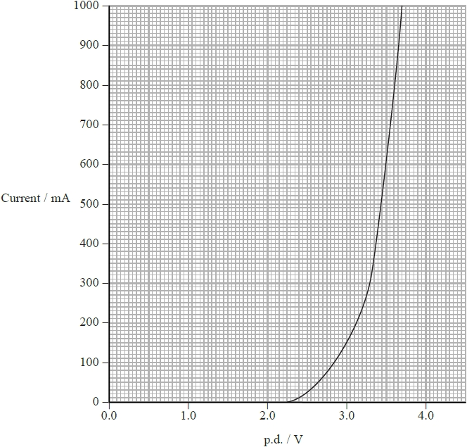

(a)  Determine the resistance of the LED when the p.d. across it is 3.5 V.

**(2)**

Resistance = ...........................................................

(b)  Describe what happens to the resistance of the LED as the p.d. across it increases from 0 V.

**(2)**

....................................................................................................................................................................................................................................

....................................................................................................................................................................................................................................

(c)  LEDs can be used to estimate the value of the Planck constant *h*.

LEDs emit photons when electrons fall from the conduction band to the valence band.

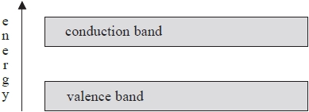

A current is produced and light is emitted only when the p.d. is great enough to supply an electron with energy equal to the gap between the conduction band and the valence band.

The p.d. is increased from zero. The value of p.d. at which there is first a current and light is first emitted is recorded. The frequency of the light is measured at this point.

A student records the frequency of 5.7 × 1014 Hz for the LED producing the graph. Carry out an appropriate calculation and evaluate the success of this technique at determining the value of the threshold value of the LED in eV.

**(4)**

....................................................................................................................................................................................................................................

....................................................................................................................................................................................................................................

....................................................................................................................................................................................................................................

....................................................................................................................................................................................................................................

....................................................................................................................................................................................................................................

....................................................................................................................................................................................................................................

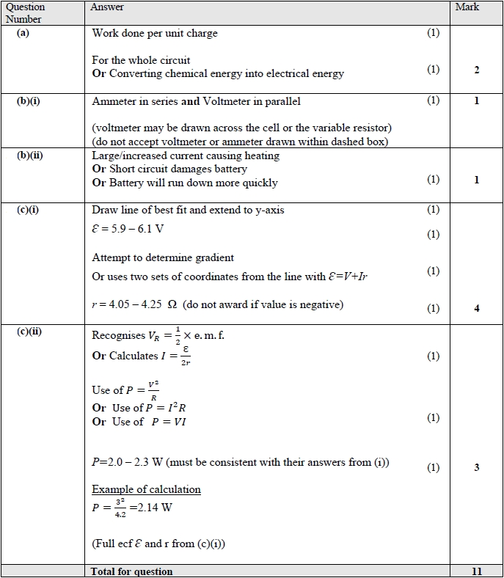

**Q2.**



**Q3.**



**Q4.**



**Q5.**

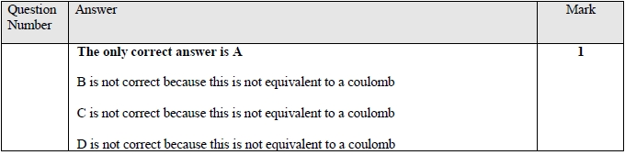

**Q6.**

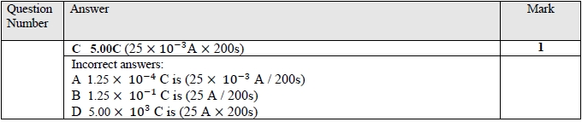

**Q7.**

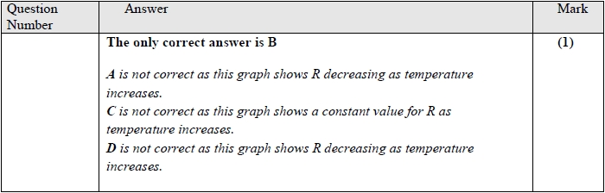

**Q8.**



**Q9.**

